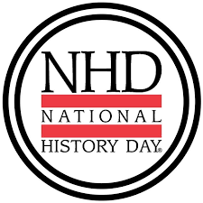
We are excited to announce that we are participating in Arkansas History Day!
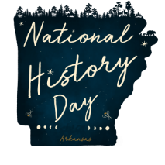

What is History Day?
National History Day (NHD) was established in 1974 and is a nonprofit education organization dedicated to improving the teaching and learning of History. Arkansas has a state program connected to the National Program.
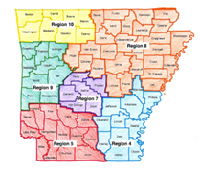

We are in Region _____
Our next deadline is _____________

Those that advance from Regionals will continue to the State Competition that will be held in Conway at the University of Central Arkansas on April 22nd.
This year’s theme is Frontiers in History: People, Places, and Ideas.
You need to pick a topic related to the theme and begin researching. We will brainstorm at the meeting on the 27th. A good topic will have primary sources (written by those who lived at the time) as well as secondary sources (written later by historians). “Time needs to pass before historians feel a topic is complete enough to understand what happened, what led to it, and why it matters. Current events are not good topics for NHD projects, but your questions about current events may lead you to similar examples in history that also interest you.” (NHD rulebook. P.7) As a rule of thumb a topic needs to be at least 20 years old.
If your student is interested in an Arkansas related topic a great starting point is the Encyclopedia of Arkansas. There “you will find a variety of entries that touch upon this theme as it relates to Arkansas history. These include sites, figures, and culture surrounding geographical and other literal frontiers; biographies of artists, scientists, and other path-breakers from Arkansas; and explorations of creative and imaginative approaches to frontiers of all kinds.” https://encyclopediaofarkansas.net/history-day-2023/
To Learn More, go to https://www.nhd.org/
Click on “For Students” and see the Theme, how to, Resources, etc.

