Sub Plan

Period---
1-Take Attendance
2-Students are researching for a project called History Day. Some students are working individually and some as a group.
They will be researching their topic for this year’s theme, “Frontiers in History: People, Places and Ideas.” They need to be taking notes or filling out Source cards like shown below as they research. Please remind them to use this research day wisely.

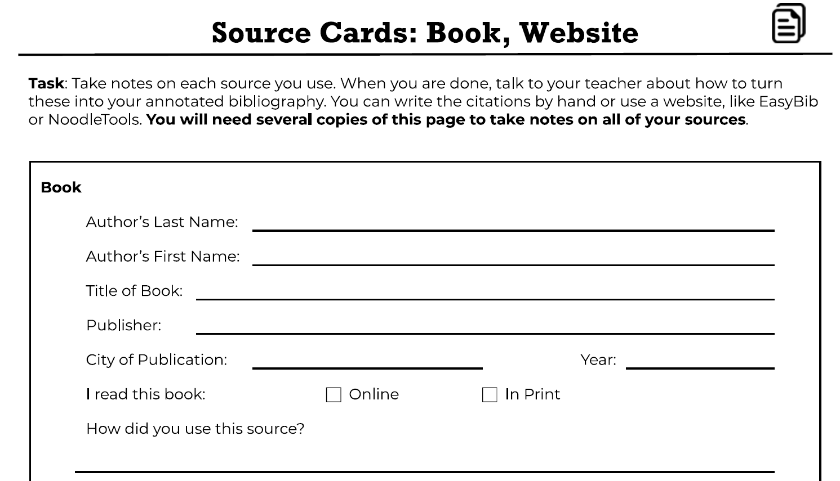

Direct anyone that says they aren’t sure of their topic or where to look to
https://www.nhd.org/student-resources
https://encyclopediaofarkansas.net/history-day-2022/
If you want to read more about this year’s theme go to https://www.nhd.org/frontiers-history
Thank you for watching my class.
Rule book pages on Research follow—as well as what constitutes Primary or Secondary Source material
