Are you ready for Regionals?
Great job on being selected to represent your school at Regionals. You should be VERY proud you made it this far. Now is the time to polish your project and make sure it is Regional Ready.

Please bring 3 copies of your Title Page, Process Paper, and Annotated Bibliography to Regionals.
Edit your Thesis again. Look at this list to check it.
Is it about 2-3 sentences long?
Does it connect your topic to the theme (Frontiers in history: People, Places, and Ideas)?
Is it a claim /argument (like a hypothesis in science class) that you proved with your project?
Does it tell why you think your topic is important in history?
Does it state the topic of your project?
Do you list a time period if needed?
Title Paper-
For your Title paper you need to list the following in 12pt Font
-Title of Project
-Your name or group members’ names
-What division- Junior or Senior?
-What category
-For exhibit or paper- your total words
-List Process paper and total number of words it has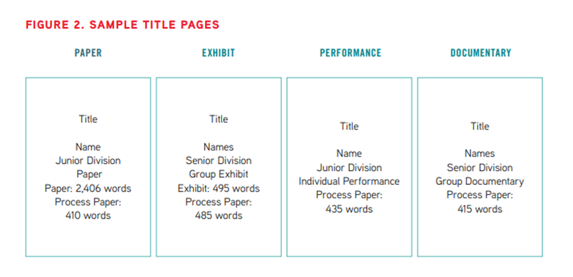
Process Paper
You will print out and turn in a process paper with every type of project you take to Regionals.
---You can write as an essay or as a “question-answer” format. NO MORE than 500 words.
- How did you choose your topic and how does it relate to the annual theme?
- How did you conduct your research?
- How did you create your project?
- What is your historical argument (thesis)?
- In what ways is your topic significant in history?

Annotated Bibliography
- List all sources you read to learn about your project even if you didn’t use any quotes from that source.
- Make sure your sources are separated into 2 parts:
Primary
Secondary
- You can use https://www.mybib.com or other easy citation sites to help you.
If you cut and paste from a google doc or the website it can put your citations in MLA or Chicago format
- Now Annotate- which means explain how you used that source.
The rule book says- Each annotation must be no more than two or three sentences.
The annotation should explain the following:
How you used the source
How the source helped you to understand the topic

